*A Parent’s Guide to Support for Personalized Learning (SPL)*

**What are the key components of the SPL process?**

The SPL framework includes the delivery of high-quality research-based instruction configured to meet the full range of student needs. SPL provides a seamless system of resources and instruction which allows students to make significant progress whether they are at-risk for failure, currently exceeding State-approved grade-level standards, or at any point along the continuum.

**INSTRUCTION**

* **CORE INSTRUCTION** is for ALL students and includes high quality curriculum and instruction in the general classroom. CORE is provided by teachers and support staff.
* **TARGETED INSTRUCTION** and customized scaffolding are triggered when a student’s progress in the general education environment, despite strong commitment and high level instruction at the CORE level, does not meet State-approved grade-level standards or exceeds State-approved grade-level standards. It differs from quality CORE instruction because of increased intensity in scaffolding, time, assessment and expertise. TARGETED may be provided by general educators, specialists and special educators.
* **INTENSIVE INSTRUCTION** is triggered when a student’s progress in the general education environment, despite rich and meaningful instruction at the CORE and TARGETED levels, continues to fall below State-approved grade-level standards. INTENSIVE support is distinguished from TARGETED support by further intensification of scaffolding, time, expertise and assessment. INTENSIVE may be provided by general educators, specialists, or special educators.

**ASSESSMENT**

* **UNIVERSAL SCREENING** means that all students are checked to determine which ones are above, at or below grade-level standards in English/language arts, mathematics and behavior.
* **PROGRESS MONITORING** occurs during TARGETED and INTENSIVE instruction to assess more specific instructional skills. Progress monitoring occurs more frequently to see how students are responding to instruction so that important decisions can be made by teachers, other school staff and parents.

**Support for Personalized Learning (SPL)**

**Good Kids Doing Great Work**

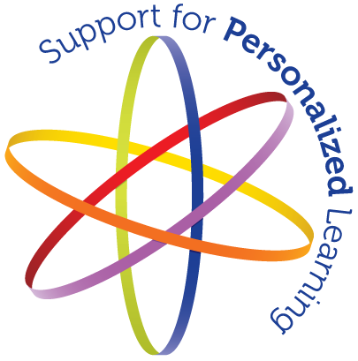

**April 2012**

**What is SPL?**

West Virginia Support for Personalized Learning (SPL) is the framework that uses a configuration of multiple supports for all students and includes the elements referred to as Response to Intervention (RTI). SPL is a multi-level process that emphasizes how students respond to instruction and provides support for students performing below State-approved grade-level standards as well as those students exceeding grade-level standards. In the early grades, teachers intervene early to prevent students from falling behind. For older students, SPL provides differentiated and scaffolded instruction to help all students with the demands of multiple learning environments. The SPL process includes problem-solving teams at the school level who examine student performance data and make recommendations for improving student achievement.

**What does SPL look like in West Virginia schools?**

In West Virginia, student’s learning is supported through a process that personalizes their instructional needs. These instructional needs are identified, monitored and evaluated through a variety of assessment processes including screening/interim, formative/classroom, progress monitoring, diagnostic and summative assessments. For some students, CORE instruction alone may not be sufficient. For these students, a multi-leveled system including, TARGETED and INTENSIVE support, progressively increases the type and amount of instruction provided.

**Support for Personalized Learning (SPL)**

**Good Kids Doing Great Work**



**How Are Parents Involved in the SPL Process?**

**Parents are important members of any child’s educational team. Being informed about your school’s SPL processes and procedures is the first step to becoming an informed, active parent participant in your child’s education. Consider asking the following questions:**

* **What does the SPL framework look like in our school? Who is providing instructional supports? When are they provided? How do you know my child needs additional instructional support?**
* **Who are the members of our school’s problem-solving teams?**
* **Is there information available about SPL such as an SPL Guidance Document? How is my child’s progress being monitored? How often will my child be screened or monitored for progress?**
* **What communication regarding my child’s progress can I expect? Who will provide the information?**
* **How will I know if my child needs TARGETED or INTENSIVE instruction?**
* **At what point in the SPL process will parents be informed of their rights under the IDEA 2004, including the right to request an evaluation for special education eligibility?**

**In addition to asking questions and receiving information from your child’s school, the West Virginia Department of Education has a number of resources available at**

[**http://wvde.state.wv.us/spl**](http://wvde.state.wv.us/spl)

[**http://wvde.state.wv.us/parents21/**](http://wvde.state.wv.us/parents21/)

**West Virginia Department of Education**

**Jorea M. Marple Ed.D.**

**State Superintendent of Schools**

What is the relationship between SPL and special education?

**As a result of the Individuals with Disabilities Education Improvement Act of 2004 (IDEA 2004), a process based on a student’s response to scientific, research-based intervention is used in West Virginia as one piece of specific information when determining whether a student has a learning disability. For some students, the three levels of support provided within general education are not enough and special education services may be needed.**

**When students participate in the SPL process, parents are to be notified about the following:**

* **The amount and nature of student performance data that would be collected and the general education services provided (i.e., multi-level instruction framework and progress monitoring data);**
* **Strategies for increasing the student’s rate of learning (i.e., research-based instruction) or for filling the gaps; and,**
* **The parent’s right to request an evaluation at any time. If a referral is made, procedures for evaluating and determining eligibility are followed as with any referral to special education.**